INDEX
CHAPTER1. INTRODUCTION
  - Introduction
  - Abstract
  - Block Diagram

CHAPTER2. DESCRIPTION OF HARDWARE COMPONENTS

2.1 ARDUINO UNO

2.1.1 Introduction

2.1.2 Need for ARDUINO

2.1.3 Types of ARDUINO Boards

2.1.4 Elements of ARDUINO BOARDS

2.1.5 Why ARDUINO?

2.1.6 ARDUINO Features

2.1.7 Pin Description

2.2 POWER SUPPLY

2.2.1 Introduction
2.2.2 Transformer Power Supply Circuit
2.2.3 Rectifier
2.2.4 Filter Capacitor

2.2.5 Regulator

2.2.6 Power Supply circuit Diagram

2.3 DHT11 SENSOR
2.4 LCD
2.5 RELAY
2.6 WATER SENSOR
2.7 DC MOTOR
2.8 HC 05 MODULE

CHAPTER3. CIRCUIT DIAGRAM
3.1 CIRCUIT DIAGARAM
3.2 SOURCE CODE

CHAPTER 4. SAMPLE PROGRAMS IN LAB
4.1.1 Example1
4.1.2 Example 2
4.1.3 Example 3
4.1.4 Example 4

CHAPTER 5. SOFTWARE DEVELOPMENT

CHAPTER 6. CONCLUSION

REFERENCES

CHAPTER 1
INTRODUCTION
1.1 INTRODUCTION
An Embedded System is a combination of computer hardware and software, and perhaps additional mechanical or other parts, designed to perform a specific function. A good example is the microwave oven. Almost every household has one, and tens of millions of them are used everyday, but very few people realize that a processor and software are involved in the preparation of their lunch or dinner.
This is in direct contrast to the personal computer in the family room. It too is comprised of computer hardware and software and mechanical components (disk drives, for example). However, a personal computer is not designed to perform a specific function rather; it is able to do many different things. Many people use the term general-purpose computer to make this distinction clear. As shipped, a general-purpose computer is a blank slate; the manufacturer does not know what the customer will do wish it. One customer may use it for a network file server another may use it exclusively for playing games, and a third may use it to write the next great American novel.
Frequently, an embedded system is a component within some larger system. For example, modern cars and trucks contain many embedded systems. One embedded system controls the anti-lock brakes, other monitors and controls the vehicle's emissions, and a third displays information on the dashboard. In some cases, these embedded systems are connected by some sort of a communication network, but that is certainly not a requirement.
At the possible risk of confusing you, it is important to point out that a general-purpose computer is itself made up of numerous embedded systems. For example, my computer consists of a keyboard, mouse, video card, modem, hard drive, floppy drive, and sound card-each of which is an embedded system. Each of these devices contains a processor and software and is designed to perform a specific function. For example, the modem is designed to send and receive digital data over analog telephone line. That's it and all of the other devices can be summarized in a single sentence as well.
If an embedded system is designed well, the existence of the processor and software could be completely unnoticed by the user of the device. Such is the case for a microwave oven, VCR, or alarm clock. In some cases, it would even be possible to build an equivalent device that does not contain the processor and software. This could be done by replacing the combination with a custom integrated circuit that performs the same functions in hardware. However, a lot of flexibility is lost when a design is hard-cooled in this way. It is mush easier, and cheaper, to change a few lines of software than to redesign a piece of custom hardware.

History and Future:
Given the definition of embedded systems earlier is this chapter; the first such systems could not possibly have appeared before 1971. That was the year Intel introduced the world's first microprocessor. This chip, the 4004, was designed for use in a line of business calculators produced by the Japanese Company Busicom. In 1969, Busicom asked Intel to design a set of custom integrated circuits-one for each of their new calculator models. The 4004 was Intel's response rather than design custom hardware for each calculator, Intel proposed a general-purpose circuit that could be used throughout the entire line of calculators. Intel's idea was that the software would give each calculator its unique set of features.
The microcontroller was an overnight success, and its use increased steadily over the next decade. Early embedded applications included unmanned space probes, computerized traffic lights, and aircraft flight control systems. In the 1980s, embedded systems quietly rode the waves of the microcomputer age and brought microprocessors into every part of our kitchens (bread machines, food processors, and microwave ovens), living rooms (televisions, stereos, and remote controls), and workplaces (fax machines, pagers, laser printers, cash registers, and credit card readers).
It seems inevitable hat the number of embedded systems will continue to increase rapidly. Already there are promising new embedded devices that have enormous market potential; light switches and thermostats that can be central computer, intelligent air-bag systems that don't inflate when children or small adults are present, pal-sized electronic organizers and personal digital assistants (PDAs), digital cameras, and dashboard navigation systems. Clearly, individuals who possess the skills and desire to design the next generation of embedded systems will be in demand for quite some time.
Real Time Systems:
One subclass of embedded is worthy of an introduction at this point. As commonly defined, a real-time system is a computer system that has timing constraints. In other words, a real-time system is partly specified in terms of its ability to make certain calculations or decisions in a timely manner. These important calculations are said to have deadlines for completion. And, for all practical purposes, a missed deadline is just as bad as a wrong answer.
The issue of what if a deadline is missed is a crucial one. For example, if the real-time system is part of an airplane's flight control system, it is possible for the lives of the passengers and crew to be endangered by a single missed deadline. However, if instead the system is involved in satellite communication, the damage could be limited to a single corrupt data packet. The more severe the consequences, the more likely it will be said that the deadline is "hard" and thus, the system is a hard real-time system. Real-time systems at the other end of this discussion are said to have "soft" deadlines.
All of the topics and examples presented in this book are applicable to the designers of real-time system who is more delight in his work. He must guarantee reliable operation of the software and hardware under all the possible conditions and to the degree that human lives depend upon three system's proper execution, engineering calculations and descriptive paperwork.
Application Areas
Nearly 99 per cent of the processors manufactured end up in embedded systems. The embedded system market is one of the highest growth areas as these systems are used in very market segment- consumer electronics, office automation, industrial automation, biomedical engineering, wireless communication, data communication, telecommunications, transportation, military and so on.
Consumer appliances:
At home we use a number of embedded systems which include digital camera, digital diary, DVD player, electronic toys, microwave oven, remote controls for TV and air-conditioner, VCO player, video game consoles, video recorders etc. Today’s high-tech car has about 20 embedded systems for transmission control, engine spark control, air-conditioning, navigation etc. Even wristwatches are now
becoming embedded systems. The palmtops are powerful embedded systems using which we can carry out many general-purpose tasks such as playing games and word processing.
Office automation:
The office automation products using em embedded systems are copying machine, fax machine, key telephone, modem, printer, scanner etc.
Industrial automation:
Today a lot of industries use embedded systems for process control. These include pharmaceutical, cement, sugar, oil exploration, nuclear energy, electricity generation and transmission. The embedded systems for industrial use are designed to carry out specific tasks such as monitoring the temperature, pressure, humidity, voltage, current etc., and then take appropriate action based on the monitored levels to control other devices or to send information to a centralized monitoring station. In hazardous industrial environment, where human presence has to be avoided, robots are used, which are programmed to do specific jobs. The robots are now becoming very powerful and carry out many interesting and complicated tasks such as hardware assembly.
Medical electronics:
Almost every medical equipment in the hospital is an embedded system. These equipments include diagnostic aids such as ECG, EEG, blood pressure measuring devices, X-ray scanners; equipment used in blood analysis, radiation, colonscopy, endoscopy etc. Developments in medical electronics have paved way for more accurate diagnosis of diseases.
Computer networking:
Computer networking products such as bridges, routers, Integrated Services Digital Networks (ISDN), Asynchronous Transfer Mode (ATM), X.25 and frame relay switches are embedded systems which implement the necessary data communication protocols. For example, a router interconnects two networks. The two networks may be running different protocol stacks. The router’s function is to obtain the data packets from incoming pores, analyze the packets and send them towards the destination after doing necessary protocol conversion. Most networking equipments, other than the end systems (desktop computers) we use to access the networks, are embedded systems
. Telecommunications:
In the field of telecommunications, the embedded systems can be categorized as subscriber terminals and network equipment. The subscriber terminals such as key telephones, ISDN phones, terminal adapters, web cameras are embedded systems. The network equipment includes multiplexers, multiple access systems, Packet Assemblers Dissemblers (PADs), sate11ite modems etc. IP phone, IP gateway, IP gatekeeper etc. are the latest embedded systems that provide very low-cost voice communication over the Internet.
Wireless technologies:
Advances in mobile communications are paving way for many interesting applications using embedded systems. The mobile phone is one of the marvels of the last decade of the 20’h century. It is a very powerful embedded system that provides voice communication while we are on the move. The Personal Digital Assistants and the palmtops can now be used to access multimedia services over the Internet. Mobile communication infrastructure such as base station controllers, mobile switching centers are also powerful embedded systems.
Insemination:
Testing and measurement are the fundamental requirements in all scientific and engineering activities. The measuring equipment we use in laboratories to measure parameters such as weight, temperature, pressure, humidity, voltage, current etc. are all embedded systems. Test equipment such as oscilloscope, spectrum analyzer, logic analyzer, protocol analyzer, radio communication test set etc. are embedded systems built around powerful processors. Thank to miniaturization, the test and measuring equipment are now becoming portable facilitating easy testing and measurement in the field by field-personnel.
Security:
Security of persons and information has always been a major issue. We need to protect our homes and offices; and also the information we transmit and store. Developing embedded systems for security applications is one of the most lucrative businesses nowadays. Security devices at homes, offices, airports etc. for authentication and verification are embedded systems. Encryption devices are nearly 99 per cent of the processors that are manufactured end up in~ embedded systems. Embedded systems find applications in . every industrial segment- consumer electronics, transportation, avionics, biomedical engineering, manufacturing, process control and industrial automation, data communication, telecommunication, defense, security etc. Used to encrypt the data/voice being transmitted on communication links such as telephone lines. Biometric systems using fingerprint and face recognition are now being extensively used for user authentication in banking applications as well as for access control in high security buildings.
Finance:
Financial dealing through cash and cheques are now slowly paving way for transactions using smart cards and ATM (Automatic Teller Machine, also expanded as Any Time Money) machines. Smart card, of the size of a credit card, has a small micro-controller and memory; and it interacts with the smart card reader! ATM machine and acts as an electronic wallet. Smart card technology has the capability of ushering in a cashless society. Well, the list goes on. It is no exaggeration to say that eyes wherever you go, you can see, or at least feel, the work of an embedded system!

1.2 ABSTRACT
Pet ownership has been increasing at a steady pace in the last 20 years. After cats and dogs, the most popular pet is now the freshwater fish. The maintenance of fish aquariums is a very difficult task itself. Whenever you have to clean up your aquarium or you have to feed, you have to do a lot of things. You have to turn off your aquarium's powerhead/air pump and feed manually and turn on the air again after an hour. In the current system, all equipment such as light, heater, and filter are to be controlled manually using electrical switches. For this, the person needs to come near the aquarium and manually control the electrical switches to turn on /off the equipment. The fishes need to be fed twice a day even this requires the owner to walk up to the fish tank and feed the fish manually which makes the task of maintaining an aquarium much more difficult. At times when the owner is on vacation, he has no control over the aquarium and also can’t feed the fish. The project with which we came up is a Smart Aquarium. The project will be more efficient than the systems available in the market nowadays. In addition to the efficiency, it will be of lower cost as well. The project’s audience is the group of people interested in keeping fish at home or offices but doesn’t have time to take care of, or they are worried to keep asking their neighbors to take care of the fishes in their absence. The project is an automated system to take care of fish. It will replace the manual maintenance of fish aquariums with its automated functions. The Smart aquarium system is a simple system that helps a user to monitor the different conditions of water like temperature, pH value, and turbidity of water. Also, it allows the user to perform actions like fish feeding and controlling temperature using a motor.
In modern days, many people have fish as their pets at home. The fishes have been fed by the aquarist in the aquarium tanks which demands a proper setup for maintenance. The problems faced are changes in water quality, feeding the fish, maintaining the temperature, controlling the lights, and difficulty checking the conditions of an aquarium manually. Therefore, it\'s necessary to monitor the physical parameters closely and enhance the water condition. So, this project proposes a system that is equipped with sensors to be operated in real-time. It performs temperature monitoring, water pH level detection, turbidity detection, and fish feeding

1.3 BLOCK DIAGRAM

ARDUINO UNO
LCD
DHT11

RELAY
MOTOR
WATER SENSOR
HC 05 MODULE
FEEDER
CHAPTER 2
DESCRIPTION OF HARDWARE COMPONENTS
2.1.1. General description of ARDUINO
Arduino is an open source microcontroller which can be easily programmed, erased and reprogrammed at any instant of time. Introduced in 2005 the Arduino platform was designed to provide an inexpensive and easy way for hobbyists, students and professionals to create devices that interact with their environment using sensors and actuators. Based on simple microcontroller boards, it is an open source computing platform that is used for constructing and programming electronic devices. It is also capable of acting as a mini computer just like other microcontrollers by taking inputs and controlling the outputs for a variety of electronics devices. It is also capable of receiving and sending information over the internet with the help of various Arduino shields, which are discussed in this paper. Arduino uses a hardware known as the Arduino development board and software for developing the code known as the Arduino IDE (Integrated Development Environment). Built up with the 8-bit Atmel AVR microcontroller's that are manufactured by Atmel or a 32-bit Atmel ARM, these microcontrollers can be programmed easily using the C or C++ language in the Arduino IDE. Unlike the other microcontroller boards in India, the Arduino boards entered the electronic market only a couple of years ago, and were restricted to small scale projects only. People associated with electronics are now gradually coming up and accepting the role of Arduino for their own projects. This development board can also be used to burn (upload) a new code to the board by simply using a USB cable to upload. The Arduino IDE provides a simplified integrated platform which can run on regular personal computers and allows users to write programs for Arduino using C or C++. With so many Arduino boards available in the market, selecting a particular development board needs a variety of survey done with respect to their specifications and capabilities, which can be used for the project execution according to its specified applications.

2.1.2 Need for ARDUINO
Why is there a need to use Arduino in specific? or What makes it different from others? Massimo Banzi, a Co-founder of Arduino mentions some very important reasons for this question.
1) Active User Community:
A group of people using a similar product can hold posted message conversations and share their experiences or solve the problems of the other users in the communities with their own experiences [1]. “If you start charging for everything, everything dies very quickly.” says Banzi, Arduino Cofounder.

2) Growth of Arduino:
Arduino was developed with intent to provide an economical and trouble-free way for hobbyists, students and professionals to build devices that interact with their situation using sensors and actuators. This makes it perfect for newcomers to get started quickly [1].

3) Inexpensive Hardware:
Since Arduino is an open source platform the software is not purchased and only the cost of buying the board or its parts is incurred, thus making it very cheap. The hardware designs are also available online for free from its official website [1].

4) Arduino Board as a Programmer:
To make Arduino board function easy and also making it available everywhere these boards come with a USB cable for power requirements as well as functioning as a programmer [1]. 5) Multi-platform Environment: The Arduino IDE is capable of running on a number of platforms including Microsoft, Linux and Mac OS X making the user community even larger [1].

2.1.3. Type of ARDUINO Boards
Arduino boards are available with many different types of built-in modules in it. Boards such as
Arduino BT come with a built-in Bluetooth module, for wireless communication. These built-in modules can also be available separately which can then be interfaced (mounted) to it. These modules are known as Shield. Some of the most commonly used Shields are:
Arduino Ethernet shield: It that allows an Arduino board to connect to the internet using the Ethernet library and to read and write an SD card using the SD library [2].
Arduino Wireless shield: It allows your Arduino board to communicate wirelessly using Zigbee [2].
Arduino Motor Driver Shield: It allows your Arduino boards to interface with driver of a motor etc. [2].

2.1.4. Elements of ARDUINO Boards
Elements of an Arduino Board can be done into two categories:
• Hardware
• Software
Hardware The Arduino Development Board consists of many components that together makes it work. Here are some of those main component blocks that help in its functioning:
Microcontroller: This is the heart of the development board, which works as a mini computer and can receive as well as send information or command to the peripheral devices connected to it. The microcontroller used differs from board to board; it also has its own various specifications.
External Power Supply: This power supply is used to power the Arduino development board with a regulated voltage ranging from 9 – 12 volts.
USB plug: This plug is a very important port in this board. It is used to upload (burn) a program to the microcontroller using a USB cable. It also has a regulated power of 5V which also powers the Arduino board in cases when the External Power Supply is absent.
Internal Programmer: The developed software code can be uploaded to the microcontroller via USB port, without an external programmer.
Reset button: This button is present on the board and can be used to resets the Arduino microcontroller.
Analog Pins: There are some analog input pins ranging from A0 – A7 (typical). These pins are used for the analog input / output. The no. of analog pins also varies from board to board.
Digital I/O Pins: There are some digital input pins also ranging from 2 to 16 (typical). These pins are used for the digital input / output. The no. of these digital pins also varies from board to board.
Power and GND Pins: There are pins on the development board that provide 3.3, 5 volts and ground through them.
Software
The program code written for Arduino is known as a sketch. The software used for developing such sketches for an Arduino is commonly known as the Arduino IDE. This IDE contains the following parts in it:
Text editor: This is where the simplified code can be written using a simplified version of C++ programming language.

Message area: It displays error and also gives a feedback on saving and exporting the code.

Text: The console displays text output by the Arduino environment including complete error messages and other information

Console Toolbar: This toolbar contains various buttons like Verify, Upload, New, Open, Save and Serial Monitor. On the bottom right hand

2.1.5 Why ARDUINO?
Thanks to its simple and accessible user experience, Arduino has been used in thousands of different projects and applications. The Arduino software is easy-to-use for beginners, yet flexible enough for advanced users. It runs on Mac, Windows, and Linux. Teachers and students use it to build low cost scientific instruments, to prove chemistry and physics principles, or to get started with programming and robotics. Designers and architects build interactive prototypes, musicians and artists use it for installations and to experiment with new musical instruments. Makers, of course, use it to build many of the projects exhibited at the Maker Faire, for example. Arduino is a key tool to learn new things. Anyone - children, hobbyists, artists, programmers - can start tinkering just following the step by step instructions of a kit, or sharing ideas online with other members of the Arduino community.
There are many other microcontrollers and microcontroller platforms available for physical computing. Parallax Basic Stamp, Netmedia's BX-24, Phidgets, MIT's Handyboard, and many others offer similar functionality. All of these tools take the messy details of microcontroller programming and wrap it up in an easy-to-use package. Arduino also simplifies the process of working with microcontrollers, but it offers some advantage for teachers, students, and interested amateurs over other systems:
- Inexpensive - Arduino boards are relatively inexpensive compared to other microcontroller platforms. The least expensive version of the Arduino module can be assembled by hand, and even the pre-assembled Arduino modules cost less than \$50
- Cross-platform - The Arduino Software (IDE) runs on Windows, Macintosh OSX, and Linux operating systems. Most microcontroller systems are limited to Windows.
- Simple, clear programming environment - The Arduino Software (IDE) is easy-to-use for beginners, yet flexible enough for advanced users to take advantage of as well. For teachers, it's conveniently based on the Processing programming environment, so students learning to program in that environment will be familiar with how the Arduino IDE works.
- Open source and extensible software - The Arduino software is published as open source tools, available for extension by experienced programmers. The language can be expanded through C++ libraries, and people wanting to understand the technical details can make the leap from Arduino to the AVR C programming language on which it's based. Similarly, you can add AVR-C code directly into your Arduino programs if you want to.
- Open source and extensible hardware - The plans of the Arduino boards are published under a Creative Commons license, so experienced circuit designers can make their own version of the module, extending it and improving it. Even relatively inexperienced users can build the breadboard version of the module in order to understand how it works and save money.

2.1.6 ARDUINO Features
High performance, low power AVR® 8-bit microcontroller
- Advanced RISC architecture
- 131 powerful instructions – most single clock cycle execution 8 general purpose working registers×● 32
- Fully static operation
- Up to 16MIPS throughput at 16MHz
- On-chip 2-cycle multiplier
- High endurance non-volatile memory segments
- 32K bytes of in-system self-programmable flash program memory
- 1Kbytes EEPROM
- 2Kbytes internal SRAM
- Write/erase cycles: 10,000 flash/100,000 EEPROM
- Optional boot code section with independent lock bits
- In-system programming by on-chip boot program
- True read-while-write operation
- Programming lock for software security
- Peripheral features
- Two 8-bit Timer/Counters with separate prescaler and compare mode
- One 16-bit Timer/Counter with separate prescaler, compare mode, and capture mode
- Real time counter with separate oscillator
- Six PWM channels
- 8-channel 10-bit ADC in TQFP and QFN/MLF package
- Temperature measurement
- Programmable serial USART
- Master/slave SPI serial interface
- Byte-oriented 2-wire serial interface (Phillips I2 C compatible)
- Programmable watchdog timer with separate on-chip oscillator
- On-chip analog comparator
- Interrupt and wake-up on pin change
- Special microcontroller features
- Power-on reset and programmable brown-out detection
- Internal calibrated oscillator
- External and internal interrupt sources
- Six sleep modes: Idle, ADC noise reduction, power-save, power-down, standby, and extended standby
2.1.7 Pin Description
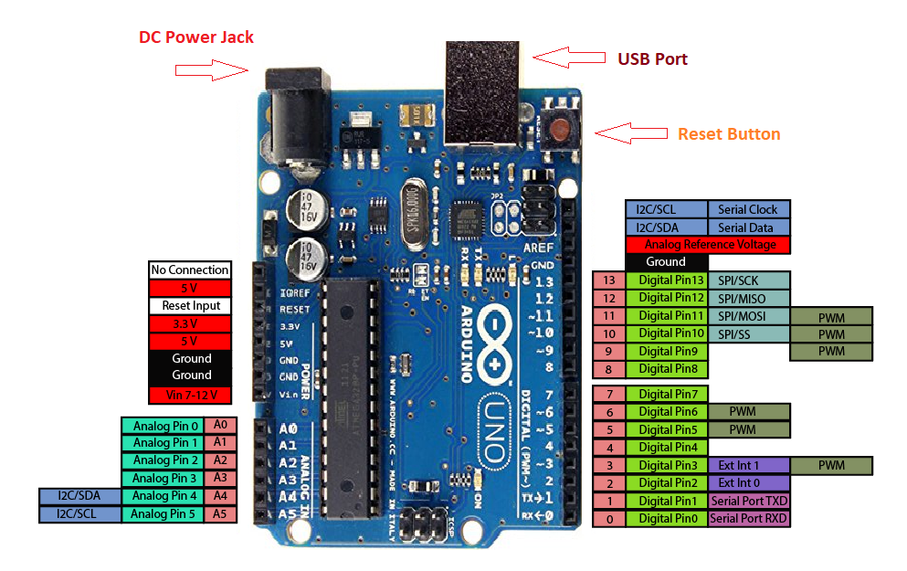
hjdsfjsgjh
Arduino Uno pinout - Power Supply
There are 3 ways to power the Arduino Uno:
- Barrel Jack - The Barrel jack, or DC Power Jack can be used to power your Arduino board. The barrel jack is usually connected to a wall adapter. The board can be powered by 5-20 volts but the manufacturer recommends to keep it between 7-12 volts. Above 12 volts, the regulators might overheat, and below 7 volts, might not suffice.
- VIN Pin - This pin is used to power the Arduino Uno board using an external power source. The voltage should be within the range mentioned above.
- USB cable - when connected to the computer, provides 5 volts at 500mA.

There is a polarity protection diode connecting between the positive of the barrel jack to the VIN pin, rated at 1 Ampere.
The power source you use determines the power you have available for your circuit. For instance, powering the circuit using the USB limits you to 500mA. Take into consideration that this is also used for powering the MCU, its peripherals, the on-board regulators, and the components connected to it. When powering your circuit through the barrel jack or VIN, the maximum capacity available is determined by the 5 and 3.3 volts regulators on-board the Arduino.
- 5v and 3v3
They provide regulated 5 and 3.3v to power external components according to manufacturer specifications.
- GND
In the Arduino Uno pinout, you can find 5 GND pins, which are all interconnected.
The GND pins are used to close the electrical circuit and provide a common logic reference level throughout your circuit. Always make sure that all GNDs (of the Arduino, peripherals and components) are connected to one another and have a common ground.
- RESET - resets the Arduino
- IOREF - This pin is the input/output reference. It provides the voltage reference with which the microcontroller operates.

Arduino Uno Pinout - Analog IN
The Arduino Uno has 6 analog pins, which utilize ADC (Analog to Digital converter).
These pins serve as analog inputs but can also function as digital inputs or digital outputs.

Analog to Digital Conversion
ADC stands for Analog to Digital Converter. ADC is an electronic circuit used to convert analog signals into digital signals. This digital representation of analog signals allows the processor (which is a digital device) to measure the analog signal and use it through its operation. Arduino Pins A0-A5 are capable of reading analog voltages. On Arduino the ADC has 10-bit resolution, meaning it can represent analog voltage by 1,024 digital levels. The ADC converts voltage into bits which the microprocessor can understand.
One common example of an ADC is Voice over IP (VoIP). Every smartphone has a microphone that converts sound waves (voice) into analog voltage. This goes through the device’s ADC, gets converted into digital data, which is transmitted to the receiving side over the internet.
Arduino Uno Pinout - Digital Pins
Pins 0-13 of the Arduino Uno serve as digital input/output pins.
Pin 13 of the Arduino Uno is connected to the built-in LED.
In the Arduino Uno - pins 3,5,6,9,10,11 have PWM capability.
It’s important to note that:
Each pin can provide/sink up to 40 mA max. But the recommended current is 20 mA.
The absolute max current provided (or sank) from all pins together is 200mA

What does digital mean?
Digital is a way of representing voltage in 1 bit: either 0 or 1. Digital pins on the Arduino are pins designed to be configured as inputs or outputs according to the needs of the user. Digital pins are either on or off. When ON they are in a HIGH voltage state of 5V and when OFF they are in a LOW voltage state of 0V.
On the Arduino, When the digital pins are configured as output, they are set to 0 or 5 volts.
When the digital pins are configured as input, the voltage is supplied from an external device. This voltage can vary between 0-5 volts which is converted into digital representation (0 or 1). To determine this, there are 2 thresholds:
● Below 0.8v - considered as 0.
● Above 2v - considered as 1.
When connecting a component to a digital pin, make sure that the logic levels match. If the voltage is in between the thresholds, the returning value will be undefined.

What is PWM?
In general, Pulse Width Modulation (PWM) is a modulation technique used to encode a message into a pulsing signal. A PWM is comprised of two key components: frequency and duty cycle. The PWM frequency dictates how long it takes to complete a single cycle (period) and how quickly the signal fluctuates from high to low. The duty cycle determines how long a signal stays high out of the total period. Duty cycle is represented in percentage.
In Arduino, the PWM enabled pins produce a constant frequency of ~ 500Hz, while the duty cycle changes according to the parameters set by the user. See the following illustration:

PWM signals are used for speed control of DC motors, dimming LEDs and more.

Communication Protocols
Serial (TTL) - Digital pins 0 and 1 are the serial pins of the Arduino Uno.
They are used by the onboard USB module.

What is Serial Communication?
Serial communication is used to exchange data between the Arduino board and another serial device such as computers, displays, sensors and more. Each Arduino board has at least one serial port. Serial communication occurs on digital pins 0 (RX) and 1 (TX) as well as via USB. Arduino supports serial communication through digital pins with the SoftwareSerial Library as well. This allows the user to connect multiple serial-enabled devices and leave the main serial port available for the USB.
Software serial and hardware serial - Most microcontrollers have hardware designed to communicate with other serial devices. Software serial ports use a pin-change interrupt system to communicate. There is a built-in library for Software Serial communication. Software serial is used by the processor to simulate extra serial ports. The only drawback with software serial is that it requires more processing and cannot support the same high speeds as hardware serial.

SPI - SS/SCK/MISO/MOSI pins are the dedicated pins for SPI communication. They can be found on digital pins 10-13 of the Arduino Uno and on the ICSP headers.

What is SPI?
Serial Peripheral Interface (SPI) is a serial data protocol used by microcontrollers to communicate with one or more external devices in a bus like connection. The SPI can also be used to connect 2 microcontrollers. On the SPI bus, there is always one device that is denoted as a Master device and all the rest as Slaves. In most cases, the microcontroller is the Master device. The SS (Slave Select) pin determines which device the Master is currently communicating with.
SPI enabled devices always have the following pins:
- MISO (Master In Slave Out) - A line for sending data to the Master device
- MOSI (Master Out Slave In) - The Master line for sending data to peripheral devices
- SCK (Serial Clock) - A clock signal generated by the Master device to synchronize data transmission.

I2C - SCL/SDA pins are the dedicated pins for I2C communication. On the Arduino Uno they are found on Analog pins A4 and A5.

What is I2C?
I2C is a communication protocol commonly referred to as the “I2C bus”. The I2C protocol was designed to enable communication between components on a single circuit board. With I2C there are 2 wires referred to as SCL and SDA.
- SCL is the clock line which is designed to synchronize data transfers.
- SDA is the line used to transmit data.
Each device on the I2C bus has a unique address, up to 255 devices can be connected on the same bus.

Aref - Reference voltage for the analog inputs.

Interrupt - INT0 and INT1. Arduino Uno has two external interrupt pins.

External Interrupt - An external interrupt is a system interrupt that occurs when outside interference is present. Interference can come from the user or other hardware devices in the network. Common uses for these interrupts in Arduino are reading the frequency a square wave generated by encoders or waking up the processor upon an external event.
Arduino has two forms of interrupt:
- External
- Pin Change
There are two external interrupt pins on the ATmega168/328 called INT0 and INT1. both INT0 and INT1 are mapped to pins 2 and 3. In contrast, Pin Change interrupts can be activated on any of the pins.
Arduino Uno Pinout - ICSP Header
ICSP stands for In-Circuit Serial Programming. The name originated from In-System Programming headers (ISP). Manufacturers like Atmel who work with Arduino have developed their own in-circuit serial programming headers. These pins enable the user to program the Arduino boards’ firmware. There are six ICSP pins available on the Arduino board that can be hooked to a programmer device via a programming cable.

2.2 POWER SUPPLY
All digital circuits require regulated power supply. In this article we are going to learn how to get a regulated positive supply from the mains supply.
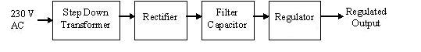
Figure 1 shows the basic block diagram of a fixed regulated power supply. Let us go through each block.
2.2.2 TRANSFORMER
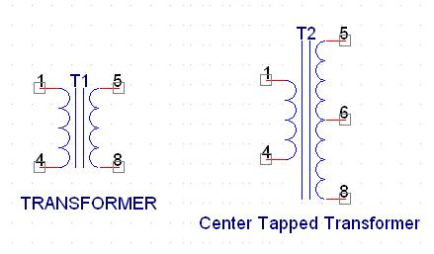
A transformer consists of two coils also called as “WINDINGS” namely PRIMARY & SECONDARY.
They are linked together through inductively coupled electrical conductors also called as CORE. A changing current in the primary causes a change in the Magnetic Field in the core & this in turn induces an alternating voltage in the secondary coil. If load is applied to the secondary then an alternating current will flow through the load. If we consider an ideal condition then all the energy from the primary circuit will be transferred to the secondary circuit through the magnetic field.
So 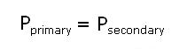
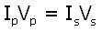
The secondary voltage of the transformer depends on the number of turns in the Primary as well as in the secondary.
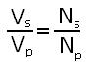
2.2.3RECTIFIER
A rectifier is a device that converts an AC signal into DC signal. For rectification purpose we use a diode, a diode is a device that allows current to pass only in one direction i.e. when the anode of the diode is positive with respect to the cathode also called as forward biased condition & blocks current in the reversed biased condition.
Rectifier can be classified as follows:
1) Half Wave rectifier.
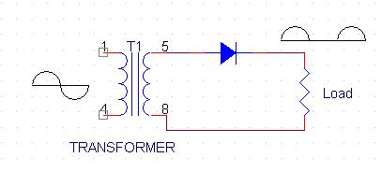
This is the simplest type of rectifier as you can see in the diagram a half wave rectifier consists of only one diode. When an AC signal is applied to it during the positive half cycle the diode is forward biased & current flows through it. But during the negative half cycle diode is reverse biased & no current flows through it. Since only one half of the input reaches the output, it is very inefficient to be used in power supplies.
2) Full wave rectifier.
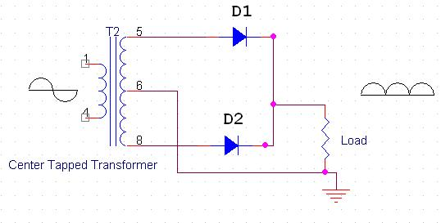
Half wave rectifier is quite simple but it is very inefficient, for greater efficiency we would like to use both the half cycles of the AC signal. This can be achieved by using a center tapped transformer i.e. we would have to double the size of secondary winding & provide connection to the center. So during the positive half cycle diode D1 conducts & D2 is in reverse biased condition. During the negative half cycle diode D2 conducts & D1 is reverse biased. Thus we get both the half cycles across the load.
One of the disadvantages of Full Wave Rectifier design is the necessity of using a center tapped transformer, thus increasing the size & cost of the circuit. This can be avoided by using the Full Wave Bridge Rectifier.
3) Bridge Rectifier.
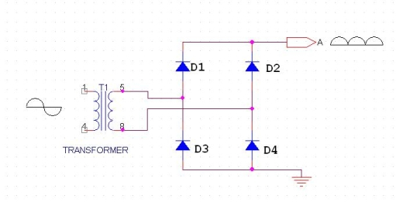
As the name suggests it converts the full wave i.e. both the positive & the negative half cycle into DC thus it is much more efficient than Half Wave Rectifier & that too without using a center tapped transformer thus much more cost effective than Full Wave Rectifier.
Full Bridge Wave Rectifier consists of four diodes namely D1, D2, D3 and D4. During the positive half cycle diodes D1 & D4 conduct whereas in the negative half cycle diodes D2 & D3 conduct thus the diodes keep switching the transformer connections so we get positive half cycles in the output.
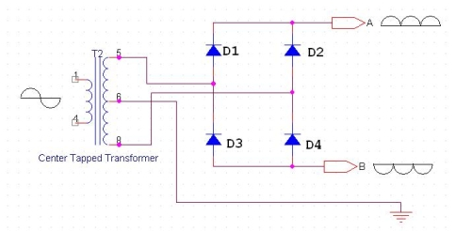
If we use a center tapped transformer for a bridge rectifier we can get both positive & negative half cycles which can thus be used for generating fixed positive & fixed negative voltages.
2.2.4 FILTER CAPACITOR
Even though half wave & full wave rectifier give DC output, none of them provides a constant output voltage. For this we require to smoothen the waveform received from the rectifier. This can be done by using a capacitor at the output of the rectifier this capacitor is also called as “FILTER CAPACITOR” or “SMOOTHING CAPACITOR” or “RESERVOIR CAPACITOR”. Even after using this capacitor a small amount of ripple will remain.
We place the Filter Capacitor at the output of the rectifier the capacitor will charge to the peak voltage during each half cycle then will discharge its stored energy slowly through the load while the rectified voltage drops to zero, thus trying to keep the voltage as constant as possible.
If we go on increasing the value of the filter capacitor then the Ripple will decrease. But then the costing will increase. The value of the Filter capacitor depends on the current consumed by the circuit, the frequency of the waveform & the accepted ripple.
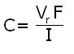
Where,
Vr= accepted ripple voltage.( should not be more than 10% of the voltage)
I= current consumed by the circuit in Amperes.
F= frequency of the waveform. A half wave rectifier has only one peak in one cycle so F=25hz
Whereas a full wave rectifier has Two peaks in one cycle so F=100hz.
2.2.5 VOLTAGE REGULATOR
A Voltage regulator is a device which converts varying input voltage into a constant regulated output voltage. Voltage regulator can be of two types
1) Linear Voltage Regulator
Also called as Resistive Voltage regulator because they dissipate the excessive voltage resistively as heat.
2) Switching Regulators.
They regulate the output voltage by switching the Current ON/OFF very rapidly. Since their output is either ON or OFF it dissipates very low power thus achieving higher efficiency as compared to linear voltage regulators. But they are more complex & generate high noise due to their switching action. For low level of output power switching regulators tend to be costly but for higher output wattage they are much cheaper than linear regulators.
The most commonly available Linear Positive Voltage Regulators are the 78XX series where the XX indicates the output voltage. And 79XX series is for Negative Voltage Regulators.
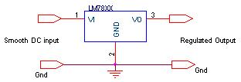
After filtering the rectifier output the signal is given to a voltage regulator. The maximum input voltage that can be applied at the input is 35V.Normally there is a 2-3 Volts drop across the regulator so the input voltage should be at least 2-3 Volts higher than the output voltage. If the input voltage gets below the Vmin of the regulator due to the ripple voltage or due to any other reason the voltage regulator will not be able to produce the correct regulated voltage.

2.2.6 CIRCUIT DIAGRAM:
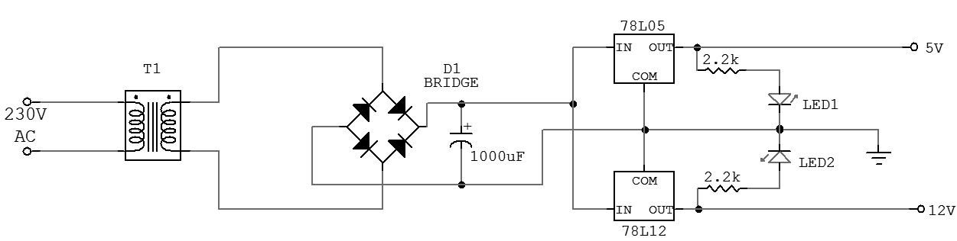
Fig 2.3. Circuit Diagram of power supply

IC 7805&7812:
7805 is an integrated three-terminal positive fixed linear voltage regulator. It supports an input voltage of 10 volts to 35 volts and output voltage of 5 volts. It has a current rating of 1 amp although lower current models are available. Its output voltage is fixed at 5.0V. The 7805 also has a built-in current limiter as a safety feature. 7805 is manufactured by many companies, including National Semiconductors and Fairchild Semiconductors.
The 7805 will automatically reduce output current if it gets too hot.The last two digits represent the voltage; for instance, the 7812 is a 12-volt regulator. The 78xx series of regulators is designed to work in complement with the 79xx series of negative voltage regulators in systems that provide both positive and negative regulated voltages, since the 78xx series can't regulate negative voltages in such a system.
The 7805 & 78 is one of the most common and well-known of the 78xx series regulators, as it's small component count and medium-power regulated 5V make it useful for powering TTL devices.
2.3 DHT11
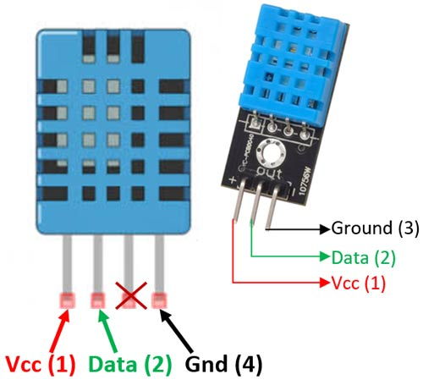
The DHT11 is a commonly used Temperature and humidity sensor that comes with a dedicated NTC to measure temperature and an 8-bit microcontroller to output the values of temperature and humidity as serial data.

DHT11 Pinout Configuration
No: | Pin Name | Description
For DHT11 Sensor
1 | Vcc | Power supply 3.5V to 5.5V
2 | Data | Outputs both Temperature and Humidity through serial Data
3 | NC | No Connection and hence not used
4 | Ground | Connected to the ground of the circuit
For DHT11 Sensor module
1 | Vcc | Power supply 3.5V to 5.5V
2 | Data | Outputs both Temperature and Humidity through serial Data
3 | Ground | Connected to the ground of the circuit
You can buy DHT11 sensor module from here.

DHT11 Specifications
- Operating Voltage: 3.5V to 5.5V
- Operating current: 0.3mA (measuring) 60uA (standby)
- Output: Serial data
- Temperature Range: 0°C to 50°C
- Humidity Range: 20% to 90%
- Resolution: Temperature and Humidity both are 16-bit
- Accuracy: ±1°C and ±1%

Difference between DHT11 Sensor and Module
The DHT11 sensor can either be purchased as a sensor or as a module. Either way, the performance of the sensor is same. The sensor will come as a 4-pin package out of which only three pins will be used whereas the module will come with three pins as shown above.
The only difference between the sensor and module is that the module will have a filtering capacitor and pull-up resistor inbuilt, and for the sensor, you have to use them externally if required.

Where to use DHT11 Sensors
The DHT11 is a commonly used Temperature and humidity sensor. The sensor comes with a dedicated NTC to measure temperature and an 8-bit microcontroller to output the values of temperature and humidity as serial data. The sensor is also factory calibrated and hence easy to interface with other microcontrollers.
The sensor can measure temperature from 0°C to 50°C and humidity from 20% to 90% with an accuracy of ±1°C and ±1%. So if you are looking to measure in this range then this sensor might be the right choice for you.

How to use DHT11 Sensor
The DHT11 Sensor is factory calibrated and outputs serial data and hence it is highly easy to set it up. The connection diagram for this sensor is shown below.
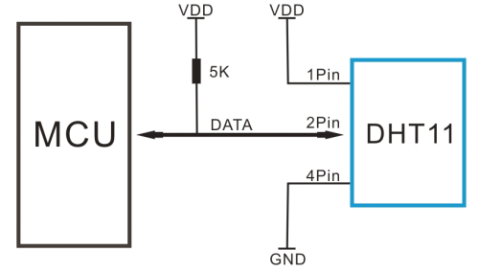

As you can see the data pin is connected to an I/O pin of the MCU and a 5K pull-up resistor is used. This data pin outputs the value of both temperature and humidity as serial data. If you are trying to interface DHT11 with Arduino then there are ready-made libraries for it which will give you a quick start.
If you are trying to interface it with some other MCU, then the datasheet given below will come in handy. The output given out by the data pin will be in the order of 8bit humidity integer data + 8bit the Humidity decimal data +8 bit temperature integer data + 8bit fractional temperature data +8 bit parity bit. To request the DHT11 module to send these data the I/O pin has to be momentarily made low and then held high as shown in the timing diagram below
The duration of each host signal is explained in the DHT11 datasheet, with neat steps and illustrative timing diagrams

Applications
- Measure temperature and humidity
- Local Weather station
- Automatic climate control
- Environment monitoring

2.4 LCD MODULE
To display interactive messages we are using LCD Module. We examine an intelligent LCD display of two lines,16 characters per line that is interfaced to the controllers. The protocol (handshaking) for the display is as shown. Whereas D0 to D7th bit is the Data lines, RS, RW and EN pins are the control pins and remaining pins are +5V, -5V and GND to provide supply. Where RS is the Register Select, RW is the Read Write and EN is the Enable pin.
The display contains two internal byte-wide registers, one for commands (RS=0) and the second for characters to be displayed (RS=1). It also contains a user-programmed RAM area (the character RAM) that can be programmed to generate any desired character that can be formed using a dot matrix. To distinguish between these two data areas, the hex command byte 80 will be used to signify that the display RAM address 00h will be chosen.Port1 is used to furnish the command or data type, and ports 3.2 to3.4 furnish register select and read/write levels.
The display takes varying amounts of time to accomplish the functions as listed. LCD bit 7 is monitored for logic high (busy) to ensure the display is overwritten.
Liquid Crystal Display also called as LCD is very helpful in providing user interface as well as for debugging purpose. The most common type of LCD controller is HITACHI 44780 which provides a simple interface between the controller & an LCD. These LCD's are very simple to interface with the controller as well as are cost effective.
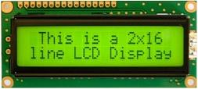
2x16 Line Alphanumeric LCD Display
The most commonly used ALPHANUMERIC displays are 1x16 (Single Line & 16 characters), 2x16 (Double Line & 16 character per line) & 4x20 (four lines & Twenty characters per line).
The LCD requires 3 control lines (RS, R/W & EN) & 8 (or 4) data lines. The number on data lines depends on the mode of operation. If operated in 8-bit mode then 8 data lines + 3 control lines i.e. total 11 lines are required. And if operated in 4-bit mode then 4 data lines + 3 control lines i.e. 7 lines are required. How do we decide which mode to use? It’s simple if you have sufficient data lines you can go for 8 bit mode & if there is a time constrain i.e. display should be faster then we have to use 8-bit mode because basically 4-bit mode takes twice as more time as compared to 8-bit mode.
Pin | Symbol | Function
1 | Vss | Ground
2 | Vdd | Supply Voltage
3 | Vo | Contrast Setting
4 | RS | Register Select
5 | R/W | Read/Write Select
6 | En | Chip Enable Signal
7-14 | DB0-DB7 | Data Lines
15 | A/Vee | Gnd for the backlight
16 | K | Vcc for backlight
When RS is low (0), the data is to be treated as a command. When RS is high (1), the data being sent is considered as text data which should be displayed on the screen.
When R/W is low (0), the information on the data bus is being written to the LCD. When RW is high (1), the program is effectively reading from the LCD. Most of the times there is no need to read from the LCD so this line can directly be connected to Gnd thus saving one controller line.
The ENABLE pin is used to latch the data present on the data pins. A HIGH - LOW signal is required to latch the data. The LCD interprets and executes our command at the instant the EN line is brought low. If you never bring EN low, your instruction will never be executed.
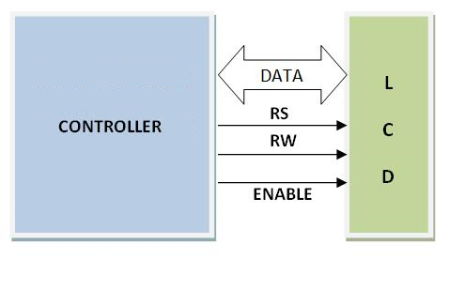
2.5 SPDT RELAY

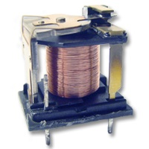

Overview OF Relays

A relay is an electrically operated switch used to isolate one electrical circuit from another. In its simplest form, a relay consists of a coil used as an electromagnet to open and close switch contacts. Since the two circuits are isolated from one another, a lower voltage circuit can be used to trip a relay, which will control a separate circuit that requires a higher voltage or amperage. Relays can be found in early telephone exchange equipment, in industrial control circuits, in car audio systems, in automobiles, on water pumps, in high-power audio amplifiers and as protection devices.

Relay Switch Contacts

The switch contacts on a relay can be "normally open" (NO) or "normally closed" (NC)--that is, when the coil is at rest and not energized (no current flowing through it), the switch contacts are given the designation of being NO or NC. In an open circuit, no current flows, such as a wall light switch in your home in a position that the light is off. In a closed circuit, metal switch contacts touch each other to complete a circuit, and current flows, similar to turning a light switch to the "on" position. In the accompanying schematic diagram, points A and B connect to the coil. Points C and D connect to the

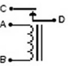

switch. When you apply a voltage across the coil at points A and B, you create an electromagnetic field, which attracts a lever in the switch, causing it to make or break contact in the circuit at points C and D (depending if the design is NO or NC). The switch contacts remain in this state until you remove the voltage to the coil. Relays come in different switch configurations. The switches may have more than one "pole," or switch contact. The diagram shows a "single pole single throw" configuration, referred to as SPST. This is similar to a wall light switch in your home. With a single "throw" of the switch, you close the circuit.

The Single Pole Double Throw Relay

A single pole double throw (SPDT) relay configuration switches one common pole to two other poles, flipping between them. As shown in the schematic diagram, the common point E completes a circuit with C when the relay coil is at rest, that is, no voltage is applied to it.

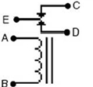

This circuit is "closed." A gap between the contacts of point E and D creates an "open" circuit. When you apply power to the coil, a metal level is pulled down, closing the circuit between points E and D and opening the circuit between E and C. A single pole double throw relay can be used to alternate which circuit a voltage or signal will be sent to.

SPDT Relay:

(Single Pole Double Throw Relay) an electromagnetic switch, consist of a coil (terminals 85 & 86), 1 common terminal (30), 1 normally closed terminal (87a), and one normally open terminal (87) (Figure 1).

When the coil of an SPDT relay (Figure 1) is at rest (not energized), the common terminal (30) and the normally closed terminal (87a) have continuity. When the coil is energized, the common terminal (30) and the normally open terminal (87) have continuity.

The diagram below center (Figure 2) shows an SPDT relay at rest, with the coil not energized. The diagram below right (Figure 3) shows the relay with the coil energized. As you can see, the coil is an electromagnet that causes the arm that is always connected to the common (30) to pivot when energized whereby contact is broken from the normally closed terminal (87a) and made with the normally open terminal (87).

When energizing the coil of a relay, polarity of the coil does not matter unless there is a diode across the coil. If a diode is not present, you may attach positive voltage to either terminal of the coil and negative voltage to the other, otherwise you must connect positive to the side of the coil that the cathode side (side with stripe) of the diode is connected and negative to side of the coil that the anode side of the diode is connected.
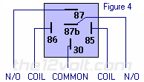

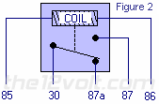
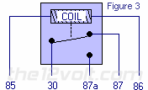

Why do I want to use a relay and do I really need to?
Anytime you want to switch a device which draws more current than is provided by an output of a switch or component you'll need to use a relay. The coil of an SPDT or an SPST relay that we most commonly use draws very little current (less than 200 milliamps) and the amount of current that you can pass through a relay's common, normally closed, and normally open contacts will handle up to 30 or 40 amps. This allows you to switch devices such as headlights, parking lights, horns, etc., with low amperage outputs such as those found on keyless entry and alarm systems, and other components. In some cases you may need to switch multiple things at the same time using one output. A single output connected to multiple relays will allow you to open continuity and/or close continuity simultaneously on multiple wires.
There are far too many applications to list that require the use of a relay, but we do show many of the most popular applications in the pages that follow and many more in our Relay Diagrams - Quick Reference application. If you are still unclear about what a relay does or if you should use one after you browse through the rest of this section, please post a question in the12volt's install bay. (We recommend Tyco (formerly Bosch) or Potter & Brumfield relays for all of the SPDT and SPST relay applications shown on this site.)

2.6 WATER SENSOR
LM324 is a 14pin IC consisting of four independent operational amplifiers (op-amps) compensated in a single package. Op-amps are high gain electronic voltage amplifier with differential input and, usually, a single-ended output. The output voltage is many times higher than the voltage difference between input terminals of an op-amp.
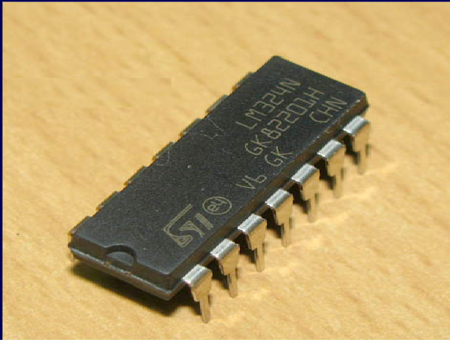
These op-amps are operated by a single power supply LM324 and need for a dual supply is eliminated. They can be used as amplifiers, comparators, oscillators, rectifiers etc. The conventional op-amp applications can be more easily implemented with LM324.
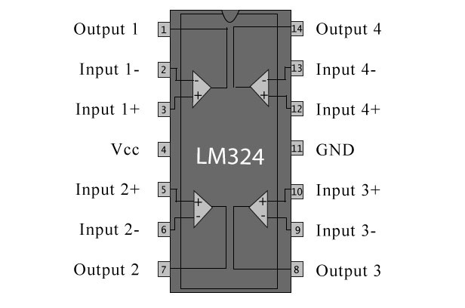
Application areas include transducer amplifiers, DC gain blocks and all the conventional op amp circuits which now can be more easily implemented in single power supply systems. For example, the LM124 series can be directly operated off of the standard +5V power supply voltage which is used in digital systems and will easily provide the required interface electronics without requiring the additional ±15V power supplies.

Unique Characteristics

In the linear mode the input common-mode voltage range includes ground and the output voltage can also swing to ground, even though operated from only a single power supply voltage the unity gain cross frequency is temperature compensated. The input bias current is also temperature compensated

Advantages

Eliminates need for dual supplies four internally compensated op amps in a single package
Allows directly sensing near GND and VOUT also goes to GND Compatible with all forms of logic Power drain suitable for battery operation.

Features

Internally frequency compensated for unity gain Large DC voltage gain 100 Db Wide and width (unity gain) 1 MHz (temperature compensated) n Wide power supply range:
Single supply 3V to 32V or dual supplies ±1.5V to ±16V Very low supply current drain (700 μA)—essentially. Independent of supply voltage Low input biasing current 45 nA (temperature compensated) Low input offset voltage 2 mV and offset current: 5 nA Input common-mode voltage range includes ground Differential input voltage range equal to the power supply voltage
Large output voltage swing 0V to V+ − 1.5V

2.7 DC MOTOR

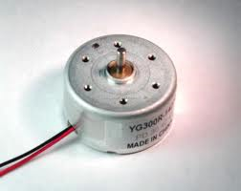
DC motors are configured in many types and sizes, including brush less, servo, and gear motor types. A motor consists of a rotor and a permanent magnetic field stator. The magnetic field is maintained using either permanent magnets or electromagnetic windings. DC motors are most commonly used in variable speed and torque.
Motion and controls cover a wide range of components that in some way are used to generate and/or control motion. Areas within this category include bearings and bushings, clutches and brakes, controls and drives, drive components, encoders and resolves, Integrated motion control, limit switches, linear actuators, linear and rotary motion components, linear position sensing, motors (both AC and DC motors), orientation position sensing, pneumatics and pneumatic components, positioning stages, slides and guides, power transmission (mechanical), seals, slip rings, solenoids, springs.
Motors are the devices that provide the actual speed and torque in a drive system. This family includes AC motor types (single and multiphase motors, universal, servo motors, induction, synchronous, and gear motor) and DC motors (brush less, servo motor, and gear motor) as well as linear, stepper and air motors, and motor contactors and starters.
In any electric motor, operation is based on simple electromagnetism. A current-carrying conductor generates a magnetic field; when this is then placed in an external magnetic field, it will experience a force proportional to the current in the conductor, and to the strength of the external magnetic field. As you are well aware of from playing with magnets as a kid, opposite (North and South) polarities attract, while like polarities (North and North, South and South) repel. The internal configuration of a DC motor is designed to harness the magnetic interaction between a current-carrying conductor and an external magnetic field to generate rotational motion.
Let's start by looking at a simple 2-pole DC electric motor (here red represents a magnet or winding with a "North" polarization, while green represents a magnet or winding with a "South" polarization).
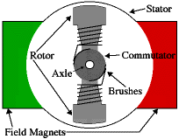
Every DC motor has six basic parts -- axle, rotor (a.k.a., armature), stator, commutator, field magnet(s), and brushes. In most common DC motors (and all that Beamers will see), the external magnetic field is produced by high-strength permanent magnets1. The stator is the stationary part of the motor -- this includes the motor casing, as well as two or more permanent magnet pole pieces. The rotor (together with the axle and attached commutator) rotates with respect to the stator. The rotor consists of windings (generally on a core), the windings being electrically connected to the commutator. The above diagram shows a common motor layout -- with the rotor inside the stator (field) magnets.
The geometry of the brushes, commutator contacts, and rotor windings are such that when power is applied, the polarities of the energized winding and the stator magnet(s) are misaligned, and the rotor will rotate until it is almost aligned with the stator's field magnets. As the rotor reaches alignment, the brushes move to the next commutator contacts, and energize the next winding. Given our example two-pole motor, the rotation reverses the direction of current through the rotor winding, leading to a "flip" of the rotor's magnetic field, and driving it to continue rotating.
In real life, though, DC motors will always have more than two poles (three is a very common number). In particular, this avoids "dead spots" in the commutator. You can imagine how with our example two-pole motor, if the rotor is exactly at the middle of its rotation (perfectly aligned with the field magnets), it will get "stuck" there. Meanwhile, with a two-pole motor, there is a moment where the commutator shorts out the power supply (i.e., both brushes touch both commutator contacts simultaneously). This would be bad for the power supply, waste energy, and damage motor components as well. Yet another disadvantage of such a simple motor is that it would exhibit a high amount of torque” ripple" (the amount of torque it could produce is cyclic with the position of the rotor).
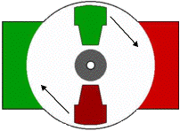
So since most small DC motors are of a three-pole design, let's tinker with the workings of one via an interactive animation (JavaScript required):
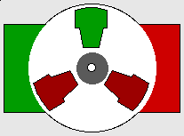
You'll notice a few things from this -- namely, one pole is fully energized at a time (but two others are "partially" energized). As each brush transitions from one commutator contact to the next, one coil's field will rapidly collapse, as the next coil's field will rapidly charge up (this occurs within a few microsecond). We'll see more about the effects of this later, but in the meantime you can see that this is a direct result of the coil windings' series wiring:
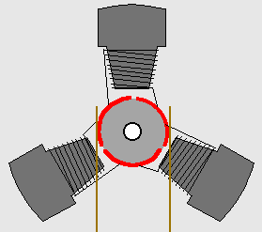
There's probably no better way to see how an average dc motor is put together, than by just opening one up. Unfortunately this is tedious work, as well as requiring the destruction of a perfectly good motor.

2.8 HC05 MODULE

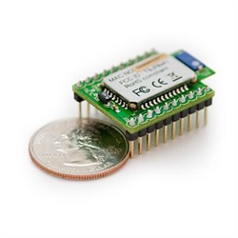

Bluetooth is an open wireless technology standard for exchanging data over short distances (using short wavelength radio transmissions) from fixed and mobile devices, creating personal area networks (PANs) with high levels of security. Created by telecoms vendor Ericsson in 1994 it was originally conceived as a wireless alternative to RS-232 data cables. It can connect several devices, overcoming problems of synchronization.

Bluetooth Overview

Why Bluetooth?
Bluetooth is a short-range radio link intended to replace the calble(s) connecting portable and/or fixed electronic devices. Key features are robustness, low complexity, low power and low cost ^{[1]}. There are already similar standards in this market, such as IrDA, HomeRF and IEEE 802.11 family. Bluetooth is designed to offer some unique advantages that none of the others can provide.
For example, IrDA uses infrared as medium, so its range is limited to around 1 meter, and it requires a line-of-sight communication. In comparison, Bluetooth can operate at a range up to 10 meters, or even 100 meters with enhanced transmitters. RF signals goes through walls, so a Bluetooth network can span several rooms.
Compared with HomeRF and IEEE 802.11 family, Bluetooth has much lower data rate and transmission range (10 meter). While HomeRF supports 1.6 ~ 10 Mbps data rate and IEEE 802.11a/b supports 54/11 Mbps, Bluetooth supports only 780 Kbps, which can be used for 721 kbps downstream and 57.6 kbps upstream asymmetric data transfer, or 432.6 kbps symmetric data transfer. Both HomeRF and IEEE 802.11 operates at 100 meter range, while Bluetooth operates at up to 10 meter.
However, as a result of the lower data rate and transmission range, Bluetooth offers much lower cost per node (approximately 5 ~ 10% of HomeRF and IEEE 802.11). So it is more suitable for applications involving low data rate (data and voice), small number of devices (8 at maximum), low power consumption and short range (up to 10 meter), such as PC-to-peripheral networking, home networking, hidden computing, data synchronization (such as between PC and PDA), mobile phone devices, and future smart devices or entertainment equipment.

Bluetooth Architecture
The Bluetooth architecture and its mapping to OSI model
Bluetooth communication occurs between a master radio and a slave radio. Bluetooth radios are symmetric in that the same device may operate as a master and also the slave. Each radio has a 48-bit unique device address (BD_ADDR) that is fixed.
Two or more radio devices together form ad-hoc networks called piconets. All units within a piconet share the same channel. Each piconet has one master device and one or more slaves. There may be up to seven active slaves at a time within a piconet. Thus, each active device within a piconet is identifiable by a 3-bit active device address. Inactive slaves in unconnected modes may continue to reside within the piconet.
A master is the only one that may initiate a Bluetooth communication link. However, once a link is established, the slave may request a master/slave switch to become the master. Slaves are not allowed to talk to each other directly. All communication occurs within the slave and the master. Slaves within a piconet must also synchronize their internal clocks and frequency hops with that of the master. Each piconet uses a different frequency hopping sequence. Radio devices used Time Division Multiplexing (TDM). A master device in a piconet transmits on even numbered slots and the slaves may transmit on odd numbered slots.
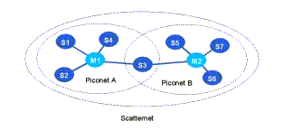
Fig 1: Bluetooth Scatternets and Piconets
Multiple piconets with overlapping coverage areas form a scatternet. Each piconet may have only one master, but slaves may participate in different piconets on a time-division multiplex basis. A device may be a master in one piconet and a slave in another or a slave in more than one piconet.
Protocols in Bluetooth Architecture

Bluetooth Core Protocols

Baseband

Link Manager Protocol

Logical Link Control and Adaptation Protocol

Service Discovery Protocol

Cable Replacement Protocol

Telephony Control Protocol

Adopted Protocols

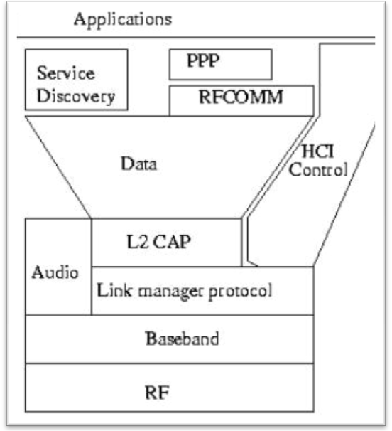
Above figure shows the Bluetooth protocol architecture.
Bluetooth technology is designed for and optimized for use in mobile devices. Mobile computers, cellular handsets, network access points, printers, PDA’s, desktops, keyboards, joysticks and virtually any other device can have short range Bluetooth radios operating in the free 2.4GHz Industrial-Scientific-Medical (ISM) band integrated into them (single chip). It uses Frequency Hop (FH) spread spectrum, which divides the frequency band into a number of hop channels. Bluetooth radios use tiny radio-frequency transmitters, no larger than 1.0 by 0.5 inches, that can run off a watch battery for months. Power considerations are always important for battery-powered mobile devices, and Bluetooth’s low power modes meet those requirements with less than 0.1 W active power. And since Bluetooth is designed for both computing and communications applications, it is designed to support high quality simultaneous voice and data, with robust data transfer rates of up to 721 Kbps. IT supports both synchronous and asynchronous services and easy integration of TCP/IP for networking purposes.
CHAPTER3
3.1 CIRCUITS DIAGRAM

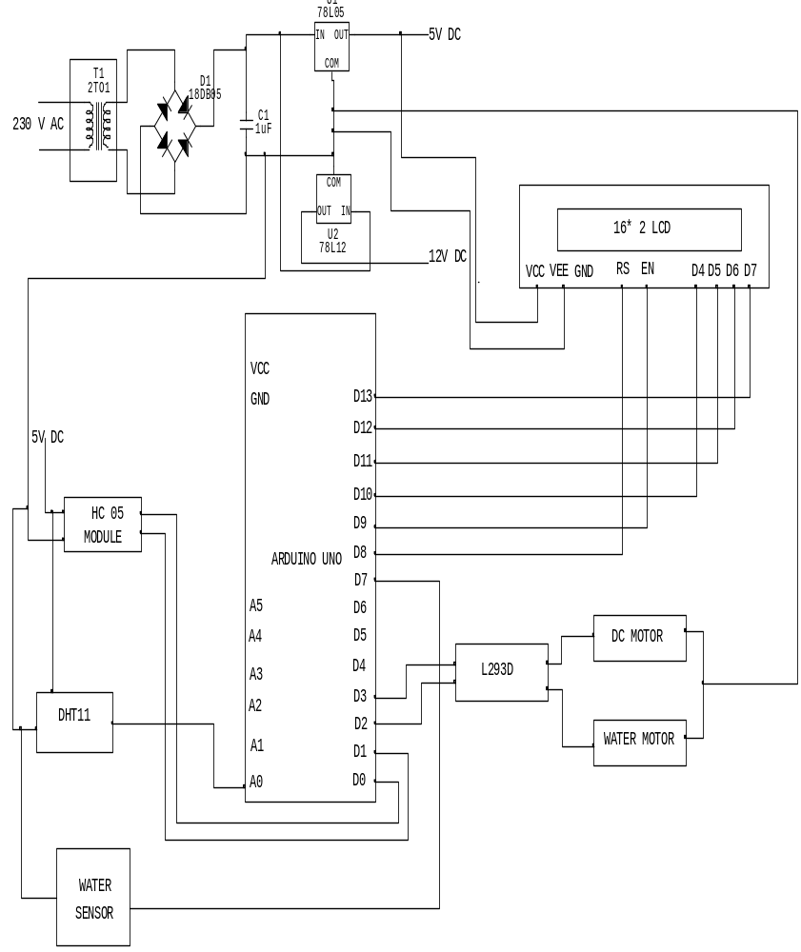

3.2 SOURCE CODE
#include <SoftwareSerial.h>
#include <LiquidCrystal.h>
#include "dht.h"
#define dataPin A0
LiquidCrystal lcd(8, 9, 10, 11, 12, 13); // 8-RS, 9-EN, 10-D4, 11-D5, 12-D6, 13-D7

SoftwareSerial bt(6,7);
#define LF 2
#define LB 3

#define water 4
#define RF A3
#define RB A4

#define DEBUG 0
dht DHT;
int temp;
int hum;
int count=0;
int timer_count=0;
int interruptPin = 1;
int value = 0;
int temp_pin = 0;
int fahrenheit = 0;

int connectionId = 0;

void title(void)
{
lcd.clear();
lcd.print("AQUARIUM MONITOR");
lcd.setCursor(0,1);
lcd.print("& AUTO CONTRL SM");
lcd.clear();
}

void setup() {
pinMode(2,OUTPUT);
pinMode(3,OUTPUT);
pinMode(A3,OUTPUT);
pinMode(A4,OUTPUT);
pinMode(4,INPUT);
lcd.clear();
lcd.begin(16, 2);
title();
lcd.clear();
title();
delay(2000);
while(!Serial){;} // waiting for serial communication to setup

bt.begin(9600);
}
void loop() {
int readData = DHT.read11(dataPin);
temp = DHT.temperature;
hum=DHT.humidity;
lcd.setCursor(0,1);
lcd.print("Tmp:");
lcd.print(temp);
lcd.print((char)223); //degree symbol
lcd.print("C ");

lcd.setCursor(10,1);
lcd.print("Hm:");
lcd.print(hum);
lcd.print("% ");

if(digitalRead(water)==1)
{
digitalWrite(RF,HIGH);
digitalWrite(RB,LOW);
lcd.setCursor(0,0);
lcd.print("WATER_STS: NO");
}
else{
digitalWrite(RF,LOW);
digitalWrite(RB,LOW);
lcd.setCursor(0,0);
lcd.print("WATER_STS: YES");
}
bt.listen(); // listening to the bluetooth

while(bt.available()) // till we are receiving the input continue in the loop
{
char ch = bt.read(); // reading one character at a time

if(ch=='A'){ // action to be performed if input is 'f'
digitalWrite(LF,HIGH);
digitalWrite(LB,LOW);
delay(500);
}
}

CHAPTER 4
SAMPLE PROGRAMS
To open the blink sketch, you will need to go to
File
> Examples
> Basics
> Blink
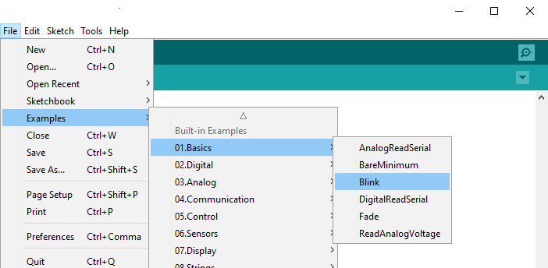
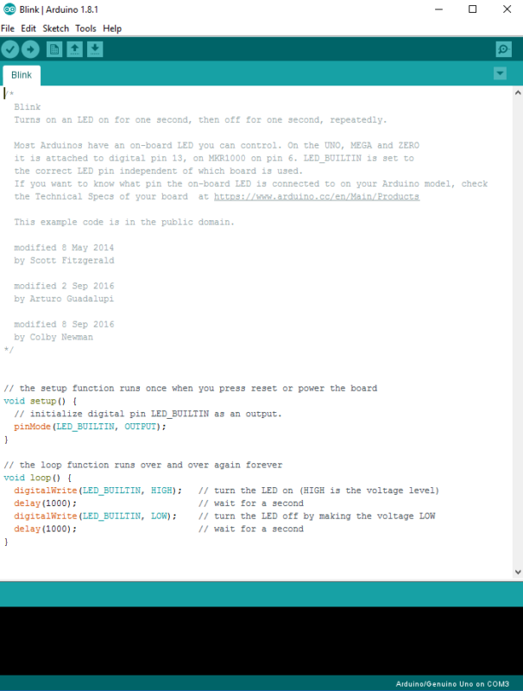
Now you should have a fully coded blink sketch that looks like the image below.

Next, you need to click on the verify button (check mark) that’s located in the top left of the IDE box. This will compile the sketch and look for errors. Once it says “Done Compiling” you are ready to upload it. Click the upload button (forward arrow) to send the program to the Arduino board.
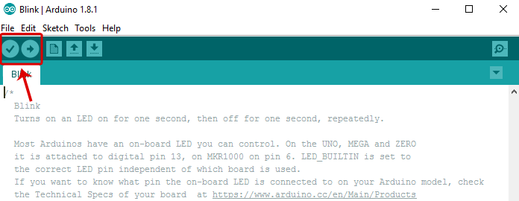
The built-in LEDs on the Arduino board will flash rapidly for a few seconds and then the program will execute. If everything went correctly, the LED on the breadboard should turn on for a second and then off for a second and continue in a loop.

Change The Code
Before we go to the next project, lets change some of the code in the “Blink” sketch to make it do something different. Playing around with the sketch will help you start to learn how the code controls the board.
Keep the Arduino board connected and change the delay portion of the code from (1000) to (200). Click the verify button on the top left of the IDE and then click upload. This should make the LED on the breadboard blink faster.
NOTE – Arduino measures time in milliseconds and 1000 milliseconds = 1 second. The original code (1000) turns on the LED for 1 second and then off for 1 second. By adjusting the code from (1000) to (200) it shortens the time between on and off which makes it blink faster.

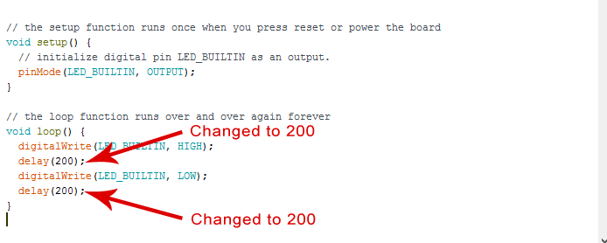

Arduino Project 2: LED w/ Switch
Now it’s time to talk switches and how they can be incorporated into Arduino projects. A switch is a electrical component that completes a circuit when pushed and breaks the circuit when released. In this project, we will be using a small pushbutton switch to control an LED.
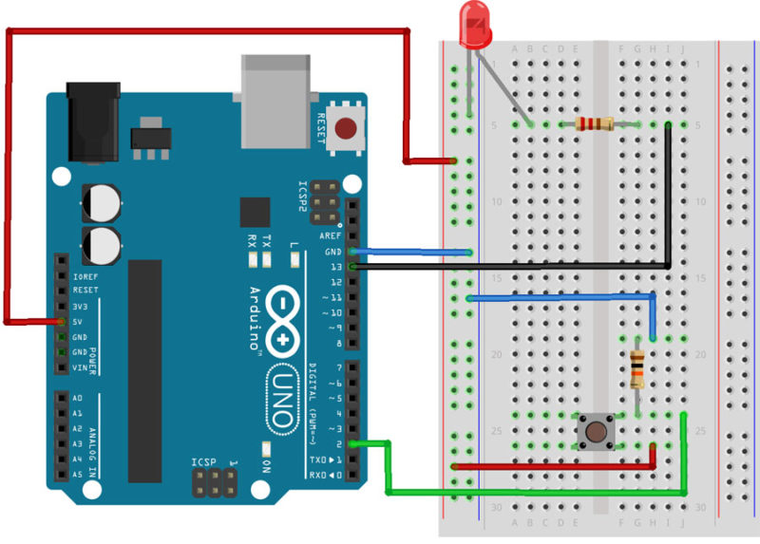

Required Parts
- Arduino Uno Board
- Breadboard – half size
- Jumper Wires
- USB Cable
- LED (5mm)
- Push button switch
- 10k Ohm Resistor
- 220 Ohm Resistor

Connect The Parts
You can build your Arduino circuit by looking at the breadboard image above or by using the written description below. In the written description, we will use a letter/number combo that refers to the location of the component. If we mention H19 for example, that refers to column H, row 19 on the breadboard.
Step 1 – Connect the blue jumper wire from the GND on the Arduino to the GND rail (blue line) on the breadboard near A13
Step 2 – Connect the blue jumper wire from the GND rail on the breadboard near A17 to H19
Step 3 – Connect the red jumper wire from the power rail on the breadboard around row A27 to H26
Step 4 – Connect the green jumper wire from pin 2 on Arduino to J24 on the breadboard
Step 5 – Place one leg of a 10k Ohm resistor in G19 and the other leg in G24
Step 6 – Place the pushbutton switch into F24, F26, E24 and E26
Step 7 – Place one leg of a 220 Ohm resistor in D5 and the other leg in G5
Step 8 – Insert the short leg of the LED in the GND rail around A5 and the long leg in B5
Step 9 – Connect the black jumper wire from pin 13 on the Arduino to I5 on the breadboard
Step 10 – Connect the red jumper wire from 5V on the Arduino to power rail (+) near A8
Step 11 – Connect the Arduino Uno to your computer via USB cable

Upload The Switch Sketch
Now it’s time to upload the sketch to the Arduino that will allow us to use a switch. As with the blink sketch, there are example programs already loaded in the Arduino IDE that we will be using.
In order to use a switch, we have to load the file called “Button” which can be found here: File
> Examples
> Digital
> Button
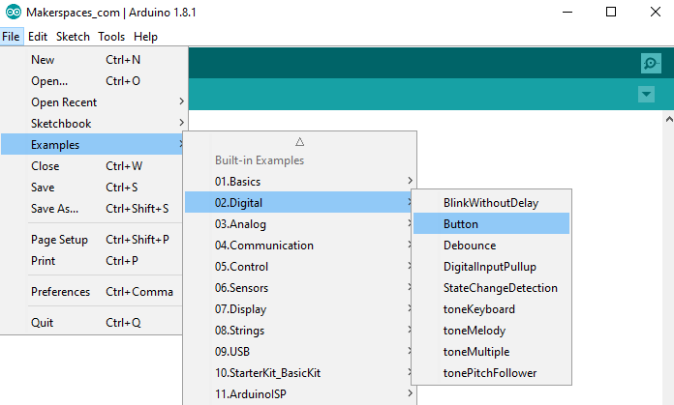
Now you should have a fully coded button sketch that looks like the image below.
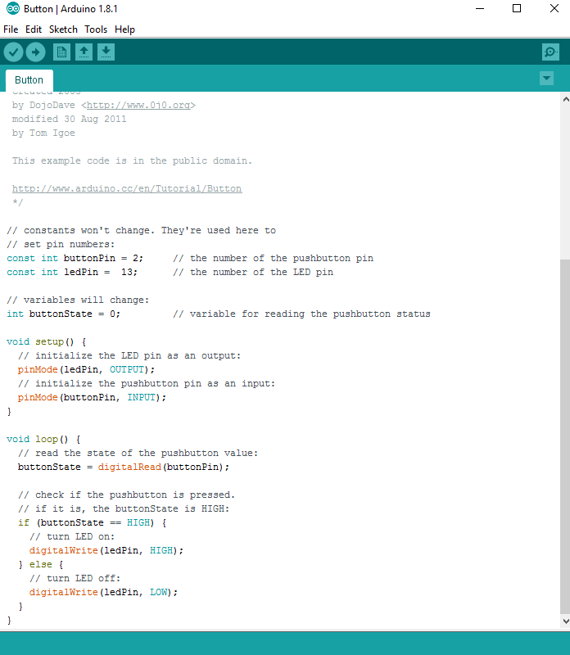
Next, you need to click on the verify button (check mark) that’s located in the top left of the IDE box. Once it says “Done Compiling” you are ready to upload it. Click the upload button (forward arrow) to send the program to the Arduino board.
CHAPTER 5
SOFTWARE DEVELOPMENT
5.1 Software Development
These are the steps you need to follow in order to be up and running:
- Get an Arduino board
- Download the Arduino environment
- Install the USB drivers
- Connect the board
- Upload a program
Get an Arduino board
The Arduino i/o board is a simple circuit featuring the ATmega8 processor from Atmel. The board is composed of a printed circuit board (PCB) and electronic parts.
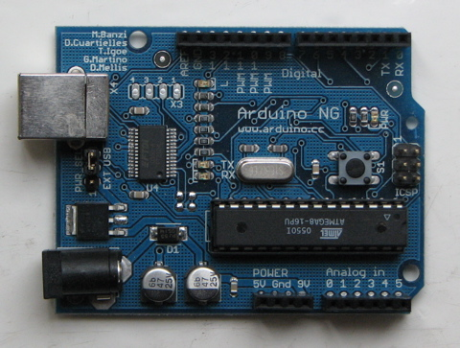
There are a few ways to get an Arduino board:
buy a ready made board. See how you can buy a board or just the PCB.
  - European distributor
  - US distributor
Build your own board. If you want you can build your own PCB just by downloading the CAD files from the Hardware page. Extract the .brd file and send it to a PCB manufacturer. Be aware that manufacturing a single pcb will be very expensive. It's better to get together with other people and make 20 or 30 at a time. Since you get the full CAD files you can make your own customised version of Arduino. if you make modifications or fix bugs please send us your changes!
Purchase parts.
Purchase the parts from any electronics store. The Serial version in particular has been designed to use the most basic parts that can be found anywhere in the world. The USB version on the other hand requires some advanced soldering skills because of the FTDI chip that is an smd part.
Assemble the board.
We put together a step by step guide on how to build an arduino board. Newbies: never soldered before? afraid of trashing thousands of boards before getting one properly soldered? fear not :) learn to master the art of soldering.

Program the boot loader.
In order for the development environment to be able to program the chip, this has to be programmed with a piece of code called bootloader. See the bootloader page on how to program it on your chip.
Download the ARDUINO environment
To program the Arduino board you need the Arduino environment.
Download Arduino: From the software page.
Linux note: For help getting the Arduino IDE running on Debian, please see the FAQ ("How can I run the Arduino IDE under Linux?").
Mac OS X note: After downloading the IDE, run the macosx_setup.command. It corrects permission on a few files for use with the serial port and will prompt you for your password. You may need to reboot after running this script.
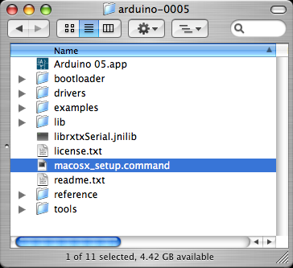
Install the USB drivers
If you are using a USB Arduino, you will need to install the drivers for the FTDI chip on the board.
These can be found in the drivers directory of the Arduino distribution.
On Windows, you will need to unzip FTDI USB Drivers.zip. Then, when you plug in the Arduino board, point the Windows Add Hardware wizard to the FTDI USB Drivers directory.
On the Mac, mount the FTDIUSBSerialDriver_v2_1_6.dmg (on PPC machines) or the FTDIUSBSerialDriver_v2_2_6_Intel.dmg (on Intel machines) disk image and run the included FTDIUSBSerialDriver.pkg.
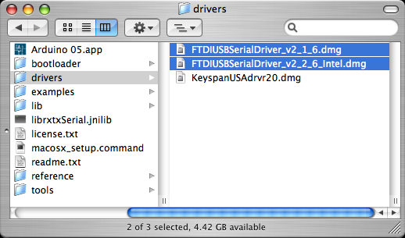
The latest version of the drivers can be found on the FTDI website.
Connect the board
If you're using a serial board, power the board with an external power supply (6 to 25 volts DC, with the core of the connector positive). Connect the board to a serial port on your computer.
On the USB boards, the power source is selected by the jumper between the USB and power plugs. To power the board from the USB port (good for controlling low power devices like LEDs), place the jumper on the two pins closest to the USB plug. To power the board from an external power supply (needed for motors and other high current devices), place the jumper on the two pins closest to the power plug. Either way, connect the board to a USB port on your computer. On Windows, the Add New Hardware wizard will open; tell it you want to specify the location to search for drivers and point to the folder containing the USB drivers you unzipped in the previous step.
The power LED should go on.
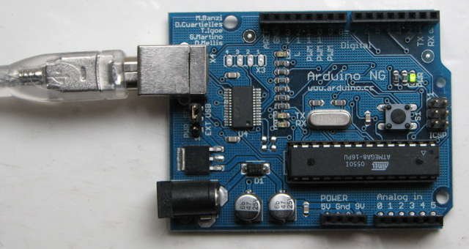
Upload a program
Open the LED blink example sketch: File > Sketchbook > Examples > led_blink.
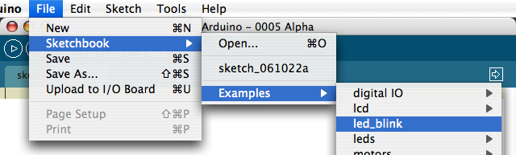
Here's what the code for the LED blink example looks like.
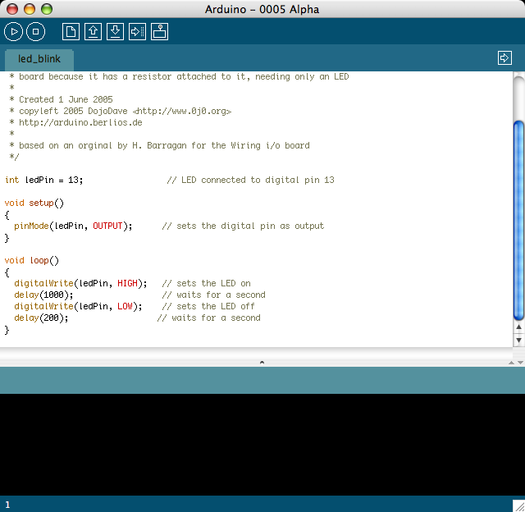
Select the serial device of the Arduino board from the Tools | Serial Port menu. On Windows, this should be COM1 or COM2 for a serial Arduino board, or COM3, COM4, or COM5 for a USB board. On the Mac, this should be something like /dev/cu.usbserial-1B1 for a USB board, or something like /dev/cu.USA19QW1b1P1.1 if using a Keyspan adapter with a serial board (other USB-to-serial adapters use different names).
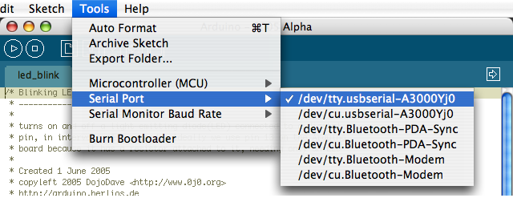
Push the reset button on the board then click the Upload button in the IDE. Wait a few seconds. If successful, the message "Done uploading." will appear in the status bar.
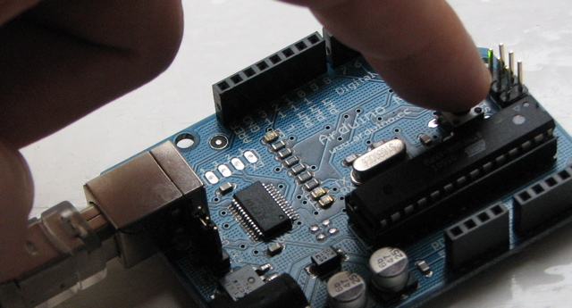
If the Arduino board doesn't show up in the Tools | Serial Port menu, or you get an error while uploading, please see the FAQ for troubleshooting suggestions.
A few seconds after the upload finishes, you should see the amber (yellow) LED on the board start to blink.

CHAPTER 6
CONCLUSION

CONCLUSION
An Arduino based mostly agriculture observance and controlling system is designed. DHT11 sensor, Soil moisture sensor is that the main sensors utilized in this project that provide the exact value of temperature, humidity, wetness content, intensity level, and soil pH severally. This technique is intended for controlling and observance environmental parameters in a very greenhouse by an easy WI-FI network.. WI-FI is additionally wont to send the information parameters to the mobile that eliminates the SMS charges. This technique reduces power consumption, maintenance, and complexness. This project is often employed in the agricultural field, in a very nursery, and within the installation..

REFERENCES
[1] S. R. Nandurkar, V. R. Thool, “Design and Development Precision Agriculture System Using Wireless Sensor Network”, IEEE International Conference on Automation, Control, Energy and Systems(ACES),2014

[2] JoaquinGutierrez, Juan Francisco Villa-Medina, Alejandra Nieto-Garibay, and Miguel Angel Porta-Gandara, “Automated Irrigation System Using a Wireless Sensor Network and GPRS Module”, IEEE TRANSACTIONS ON INSTRUMENTATION AND MEASUREMENT,0018- 9456,2013

[3] Dr. V. Vidya Devi, G. Meena Kumari, “Real- Time Automation and Monitoring System for Modernized Agriculture” , Interional Journal of Review and Research in Applied Sciences and Engineering (IJRRASE) Vol3 no.1. pp 7-12,2013

[4] Basha, Elizabeth, and Daniela Rus. “ Design of early warnimng flood detection systems for developing countries.” Information and Communication Technologies and Development, 2007. ICTD 2007. International Conference on. IEEE, 2007

[5] Danny Hughes, Phil Greenwood, Gordon Blair, Geoff Coulson, Florian pappenbeger, paul Smith and Keith Beven. An Intelligent and Adaptable Grid-based Flood Monitoring and Warning System (DRAFT). UK science All Hands Meeting 5th,2006.

[6] S. Yumuang, “2001 debris flow and debris flood in Nam Koarea, Phetchabun Province, central Thailand, “Environmental Geology(2006) 51: 545-564,2006.

[7] Sipalay Flood Control Project 2010 Available: http://goo.gl/UhkDfU.

[8] Wireless Sensor Networks Issues and Applications by Raj Kumar, Vani B A, Kiran Jadhav, Vidya S in IJCTA | Sept-Oct

